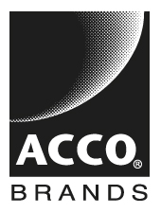

**Visit ACCO Brands at the following Universities:**

**January 2014**

**Michigan State University 1/29/14 East Lansing, MI 9:00 a.m. - 4:00 p.m.**

**Packaging fair**

**February 2014**

**Loyola University 2/11/14 Chicago, IL 4:00 p.m. - 6:00 p.m.**

**Quinlan Career Fair**

**DePaul University 2/14/14 Chicago, IL 11:00 a.m. - 3:00pm**

**Winter Career Fair**

**University of Illinois-Chicago 2/18/14 Chicago, IL 12:00 p.m. - 4:00 p.m.**

**Engineering Fair**